**RANDOM TRAINAG-NO TESTAG-NO**

3108 classified correctly

101 classified incorrectly

------------------------------------------------

Le prossime predizioni sono giuste

------------------------------------------------

Digit: '1' corrisponde a 'Speed limit (30km/h)'

Digit: '2' corrisponde a 'Speed limit (50km/h)'

Digit: '4' corrisponde a 'Speed limit (70km/h)'

Digit: '7' corrisponde a 'Priority road'

Digit: '8' corrisponde a 'Yield'

Digit: '9' corrisponde a 'Keep right'

------------------------------------------------

Le prossime predizioni sono sbagliate

------------------------------------------------

Digit: '1' corrisponde a 'Speed limit (30km/h)'

Digit: '2' corrisponde a 'Speed limit (50km/h)'

Digit: '3' corrisponde a 'Speed limit (60km/h)'

Digit: '4' corrisponde a 'Speed limit (70km/h)'

Digit: '5' corrisponde a 'Speed limit (80km/h)'

Digit: '6' corrisponde a 'No passing for vehicles over 3.5 metric tons'

Digit: '9' corrisponde a 'Keep right'

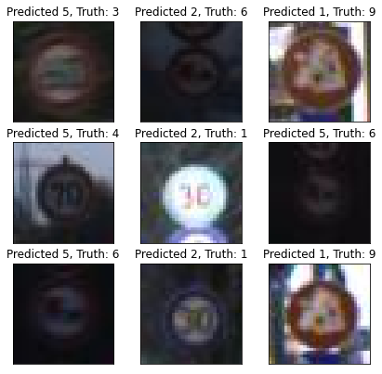

**RANDOM TRAINAG-SI TESTAG-NO**

3096 classified correctly

113 classified incorrectly

------------------------------------------------

Le prossime predizioni sono giuste

------------------------------------------------

Digit: '1' corrisponde a 'Speed limit (30km/h)'

Digit: '2' corrisponde a 'Speed limit (50km/h)'

Digit: '3' corrisponde a 'Speed limit (60km/h)'

Digit: '4' corrisponde a 'Speed limit (70km/h)'

Digit: '5' corrisponde a 'Speed limit (80km/h)'

Digit: '8' corrisponde a 'Yield'

------------------------------------------------

Le prossime predizioni sono sbagliate

------------------------------------------------

Digit: '1' corrisponde a 'Speed limit (30km/h)'

Digit: '2' corrisponde a 'Speed limit (50km/h)'

Digit: '3' corrisponde a 'Speed limit (60km/h)'

Digit: '4' corrisponde a 'Speed limit (70km/h)'

Digit: '5' corrisponde a 'Speed limit (80km/h)'

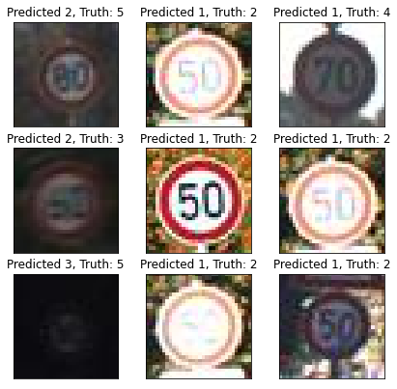

**RANDOM TRAINAG-NO TESTAG-SI**

2630 classified correctly

579 classified incorrectly

------------------------------------------------

Le prossime predizioni sono giuste

------------------------------------------------

Digit: '1' corrisponde a 'Speed limit (30km/h)'

Digit: '2' corrisponde a 'Speed limit (50km/h)'

Digit: '4' corrisponde a 'Speed limit (70km/h)'

Digit: '6' corrisponde a 'No passing for vehicles over 3.5 metric tons'

Digit: '7' corrisponde a 'Priority road'

Digit: '9' corrisponde a 'Keep right'

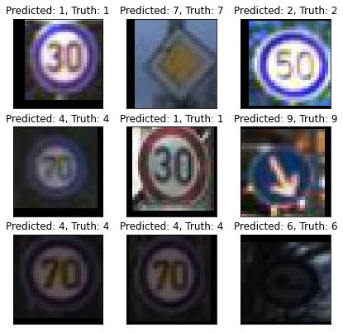

------------------------------------------------

Le prossime predizioni sono sbagliate

------------------------------------------------

Digit: '1' corrisponde a 'Speed limit (30km/h)'

Digit: '2' corrisponde a 'Speed limit (50km/h)'

Digit: '3' corrisponde a 'Speed limit (60km/h)'

Digit: '4' corrisponde a 'Speed limit (70km/h)'

Digit: '6' corrisponde a 'No passing for vehicles over 3.5 metric tons'

Digit: '7' corrisponde a 'Priority road'

Digit: '8' corrisponde a 'Yield'

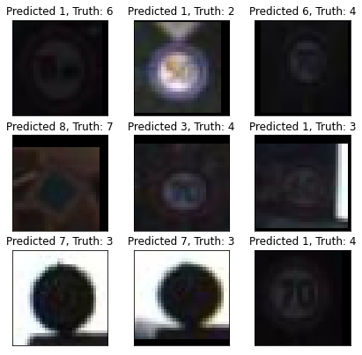

**RANDOM TRAINAG-SI TESTAG-SI**

**96%**

3089 classified correctly

120 classified incorrectly

------------------------------------------------

Le prossime predizioni sono giuste

------------------------------------------------

Digit: '1' corrisponde a 'Speed limit (30km/h)'

Digit: '2' corrisponde a 'Speed limit (50km/h)'

Digit: '3' corrisponde a 'Speed limit (60km/h)'

Digit: '4' corrisponde a 'Speed limit (70km/h)'

Digit: '6' corrisponde a 'No passing for vehicles over 3.5 metric tons'

Digit: '7' corrisponde a 'Priority road'

Digit: '8' corrisponde a 'Yield'

------------------------------------------------

Le prossime predizioni sono sbagliate

------------------------------------------------

Digit: '0' corrisponde a 'Speed limit (20km/h)'

Digit: '1' corrisponde a 'Speed limit (30km/h)'

Digit: '2' corrisponde a 'Speed limit (50km/h)'

Digit: '3' corrisponde a 'Speed limit (60km/h)'

Digit: '4' corrisponde a 'Speed limit (70km/h)'

Digit: '5' corrisponde a 'Speed limit (80km/h)'

Digit: '6' corrisponde a 'No passing for vehicles over 3.5 metric tons'

Digit: '9' corrisponde a 'Keep right'

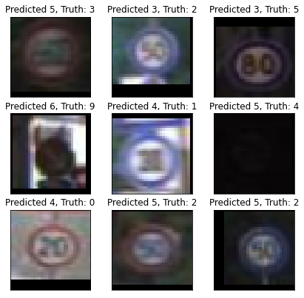

####

**88%**

2503 classified correctly

706 classified incorrectly

------------------------------------------------

Le prossime predizioni sono giuste

------------------------------------------------

Digit: '1' corrisponde a 'Speed limit (30km/h)'

Digit: '4' corrisponde a 'Speed limit (70km/h)'

Digit: '5' corrisponde a 'Speed limit (80km/h)'

Digit: '6' corrisponde a 'No passing for vehicles over 3.5 metric tons'

Digit: '8' corrisponde a 'Yield'

Digit: '9' corrisponde a 'Keep right'

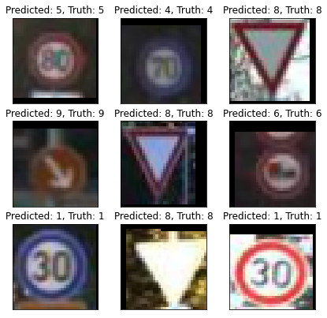

------------------------------------------------

Le prossime predizioni sono sbagliate

------------------------------------------------

Digit: '1' corrisponde a 'Speed limit (30km/h)'

Digit: '2' corrisponde a 'Speed limit (50km/h)'

Digit: '3' corrisponde a 'Speed limit (60km/h)'

Digit: '4' corrisponde a 'Speed limit (70km/h)'

Digit: '5' corrisponde a 'Speed limit (80km/h)'

Digit: '9' corrisponde a 'Keep right'

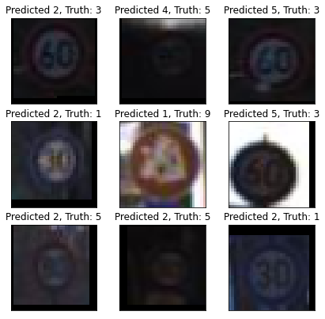

#########

**98%**

3140 classified correctly

69 classified incorrectly

------------------------------------------------

Le prossime predizioni sono giuste

------------------------------------------------

Digit: '1' corrisponde a 'Speed limit (30km/h)'

Digit: '3' corrisponde a 'Speed limit (60km/h)'

Digit: '4' corrisponde a 'Speed limit (70km/h)'

Digit: '6' corrisponde a 'No passing for vehicles over 3.5 metric tons'

Digit: '8' corrisponde a 'Yield'

Digit: '9' corrisponde a 'Keep right'

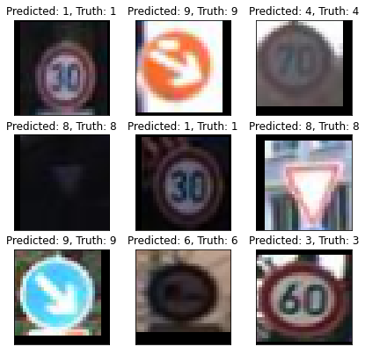

------------------------------------------------

Le prossime predizioni sono sbagliate

------------------------------------------------

Digit: '1' corrisponde a 'Speed limit (30km/h)'

Digit: '2' corrisponde a 'Speed limit (50km/h)'

Digit: '3' corrisponde a 'Speed limit (60km/h)'

Digit: '4' corrisponde a 'Speed limit (70km/h)'

Digit: '5' corrisponde a 'Speed limit (80km/h)'

Digit: '7' corrisponde a 'Priority road'

Digit: '9' corrisponde a 'Keep right'

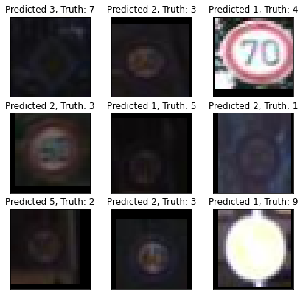

**COLAB IMPICCIONE**

Epoch 1/15

2/260 [..............................] - ETA: 45s - loss: 2.2770 - accuracy: 0.1750WARNING:tensorflow:Method (on_train_batch_end) is slow compared to the batch update (0.123772). Check your callbacks.

260/260 [==============================] - 28s 107ms/step - loss: 1.6459 - accuracy: 0.8299 - val_loss: 1.9422 - val_accuracy: 0.5150

Epoch 2/15

260/260 [==============================] - 27s 103ms/step - loss: 1.5118 - accuracy: 0.9518 - val_loss: 1.9688 - val_accuracy: 0.4846

Epoch 3/15

260/260 [==============================] - 28s 107ms/step - loss: 1.4862 - accuracy: 0.9765 - val_loss: 1.8935 - val_accuracy: 0.5592

Epoch 4/15

260/260 [==============================] - 27s 104ms/step - loss: 1.4766 - accuracy: 0.9855 - val_loss: 1.9532 - val_accuracy: 0.5034

Epoch 5/15

260/260 [==============================] - 28s 108ms/step - loss: 1.4721 - accuracy: 0.9898 - val_loss: 1.7910 - val_accuracy: 0.6687

Epoch 6/15

260/260 [==============================] - 27s 104ms/step - loss: 1.4698 - accuracy: 0.9916 - val_loss: 1.7965 - val_accuracy: 0.6632

Epoch 7/15

260/260 [==============================] - 28s 108ms/step - loss: 1.4676 - accuracy: 0.9939 - val_loss: 1.7571 - val_accuracy: 0.7000

Epoch 8/15

260/260 [==============================] - 28s 108ms/step - loss: 1.4660 - accuracy: 0.9955 - val_loss: 1.7176 - val_accuracy: 0.7428

Epoch 9/15

260/260 [==============================] - 29s 110ms/step - loss: 1.4660 - accuracy: 0.9955 - val_loss: 1.6257 - val_accuracy: 0.8358

Epoch 10/15

260/260 [==============================] - 28s 107ms/step - loss: 1.4653 - accuracy: 0.9960 - val_loss: 1.5823 - val_accuracy: 0.8797

Epoch 11/15

260/260 [==============================] - 28s 108ms/step - loss: 1.4640 - accuracy: 0.9974 - val_loss: 1.5521 - val_accuracy: 0.9088

Epoch 12/15

260/260 [==============================] - 28s 107ms/step - loss: 1.4646 - accuracy: 0.9967 - val_loss: 1.5143 - val_accuracy: 0.9475

Epoch 13/15

260/260 [==============================] - 28s 108ms/step - loss: 1.4632 - accuracy: 0.9983 - val_loss: 1.5087 - val_accuracy: 0.9530

Epoch 14/15

260/260 [==============================] - 28s 107ms/step - loss: 1.4633 - accuracy: 0.9980 - val_loss: 1.4978 - val_accuracy: 0.9646

Epoch 15/15

260/260 [==============================] - 28s 109ms/step - loss: 1.4633 - accuracy: 0.9980 - val_loss: 1.4884 - val_accuracy: 0.9738

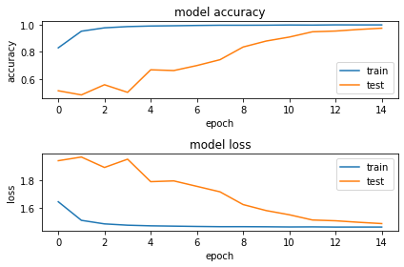



101/101 - 1s - loss: 1.4823 - accuracy: 0.9785

Test Loss 1.4823460578918457

Test Accuracy 0.9784979820251465

Tempo d'addestramento in secondi:

431.14526319503784

Tempo d'addestramento in ore-minuti-secondi-scartoRimanente:

00:07:11.15